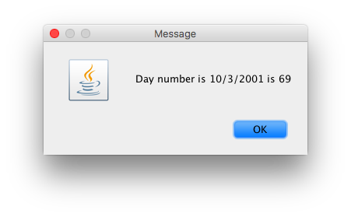

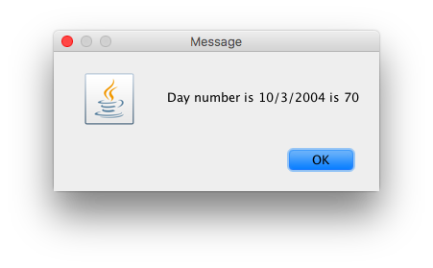

**import** javax.swing.JOptionPane;

**public** **class** TestLeapDay {

**public** **static** **void** main (String argus[]){

String in;

**int** day, month, year;

/*

in = JOptionPane.showInputDialog("Enter day");

day = Integer.parseInt(in);

in = JOptionPane.showInputDialog("Enter month");

month = Integer.parseInt(in);

in = JOptionPane.showInputDialog("Enter year");

year = Integer.parseInt(in);

Day b; //object

b = new Day(day,month);

in = "The day number for " + month +"/" + day + " is "+ year

+ b.findDayNum();

*/

in = JOptionPane.*showInputDialog*("Enter day");

day = Integer.*parseInt*(in);

in = JOptionPane.*showInputDialog*("Enter month");

month = Integer.*parseInt*(in);

in = JOptionPane.*showInputDialog*("Enter year");

year = Integer.*parseInt*(in);

LeapDay v;

v = **new** LeapDay(day,month,year);

in = "Day number is " + day + "/" + month + "/" + year + " is "

+v.findDayNum();

JOptionPane.*showMessageDialog*(**null**,in);

}

}

**public** **class** Day {

**private** **int** day;

**protected** **int** month;

**private** **int** year;

//public constructor to intialize the variable

//Format for consturctors

//public class(data_type varibale, data_type variable) {

//super();

//this.variable = variable;

//}

**public** Day(**int** day, **int** month) {

**super**();

**this**.day = day;

**this**.month = month;

}

**public** **int** getDay() {

**return** day;

}

**public** **int** getMonth() {

**return** month;

}

**public** **int** getYear() {

**return** year;

}

**public** **int** findDayNum() {

**if** (month == 2) {

day += 31;

}

**else** **if** (month == 3) {

day += 59;

}

**else** **if** (month == 4) {

day += 90;

}

**else** **if** (month == 5) {

day += 31 + 28 + 31 + 30;

}

**else** **if** (month == 6) {

day += 31 + 28 + 31 + 30 + 31;

}

**else** **if** (month == 7) {

day += 31 + 28 + 31 + 30 + 31 + 30;

}

**else** **if** (month == 8) {

day += 31 + 28 + 31 + 30 + 31 + 30 + 31;

}

**else** **if** (month == 9) {

day += 31 + 28 + 31 + 30 + 31 + 30 + 31 + 31;

}

**else** **if** (month == 10) {

day += 31 + 28 + 31 + 30 + 31 + 30 + 31 + 31 + 30;

}

**else** **if** (month == 11) {

day += 31 + 28 + 31 + 30 + 31 + 30 + 31 + 31 + 30 + 31;

}

**else** **if** (month == 12) {

day += 31 + 28 + 31 + 30 + 31 + 30 + 31 + 31 + 30 + 31 + 30;

}

**return** day;

}

}

**public** **class** LeapDay **extends** Day {

**private** **int** year;

//private int day;

//private int month;

LeapDay a;

**public** LeapDay(**int** day, **int** month, **int** year) {

**super**(day,month);

**this**.year = year;

}

**public** **int** getYear() {

//Not a leap year

**return** year;

}

**public** **int** findDayNum() {

**int** countDay;

**if** (((year % 400) == 0) || (((year % 4) == 0) && ((year%100) != 0)))

{

countDay = **super**.findDayNum();

**if** (month >=2)

countDay += 1;

**return** countDay;

}

**else**

{

countDay = **super**.findDayNum();

**return** countDay;

}

}

}